1)What are the popular methods in which decision trees are made?
2)List down the different types of nodes in Decision Trees
3)Decision tree is a ___________.
4)Entropy, Information Gain, Gini Index, Reducing Impurity?
5)How to handle a decision tree for numerical and categorical data?
6)Explain the concept of GINI Impurity.
7)Let’s suppose you have given you dataset with 100 column how you will be able to control growth of decision
8)How the leaf size is controlled in DT?
9)What are advantages of DT?
10)What are disadvantages of DT?

1)The popular ways of building DT are

1. ID3 (Iterative Dichotomiser): Uses Information Gain as attribute selection measure.
2. C4.5 (Successor of ID3): Uses Gain Ratio as attribute selection measure.
3. CART (Classification and Regression Trees) – Uses Gini Index as attribute selection measure.
2)Parent node:-The starting point of DT.
Intermediate/Internal Node:-Nodes which are created after parent node.
Leaf Node:-The node which cannot be further splitted.
3) Non-linear ML technique.
Non-Parametric technique.
Supervised Learning technique

4)There are different attributes which define the split of nodes in a decision tree. There are few algorithms to find the optimal split
1) ID3(Iterative Dichotomiser 3): This solution uses Entropy and Information gain as metrics to form a better decision tree. The attribute with the highest information gain is used as a root node, and a similar approach is followed after that. Entropy is the measure that characterizes the impurity of an arbitrary collection of examples.
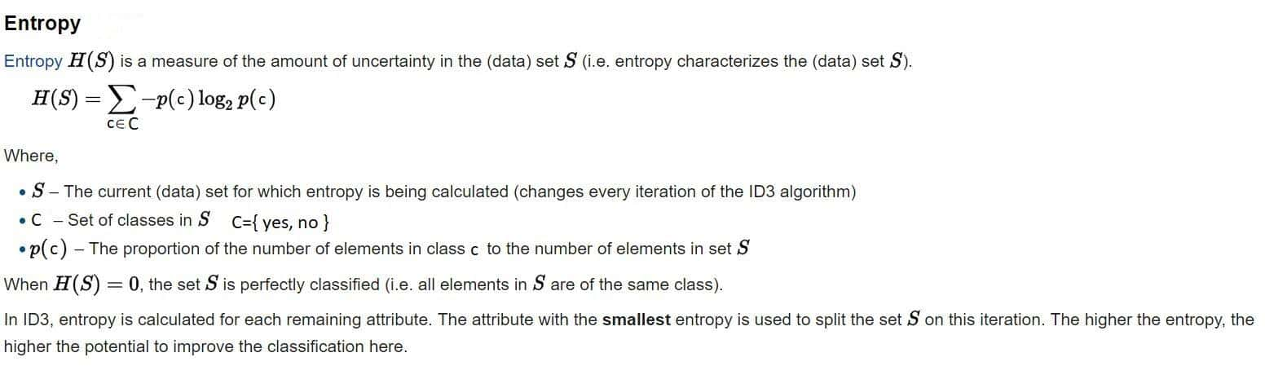
Entropy varies from 0 to 1. 0 if all the data belong to a single class and 1 if the class distribution is equal. In this way, entropy will give a measure of impurity in the dataset.
Steps to decide which attribute to split:
1. Compute the entropy for the dataset
2. For every attribute:
2.1 Calculate entropy for all categorical values.
2.2 Take average information entropy for the attribute.
2.3 Calculate gain for the current attribute.
3. Pick the attribute with the highest information gain.
4. Repeat until we get the desired tree.
A leaf node is decided when entropy is zero
Information Gain = 1 - ∑ (Sb/S)*Entropy (Sb)
Sb - Subset, S - entire data
2) CART Algorithm (Classification and Regression trees): In CART, we use the GINI index as a metric. Gini index is used as a cost function to evaluate split in a dataset
Steps to calculate Gini for a split:
1. Calculate Gini for subnodes, using formula sum of the square of probability for success and failure (p2+q2).
2. Calculate Gini for split using weighted Gini score of each node of that split.
Choose the split based on higher Gini value
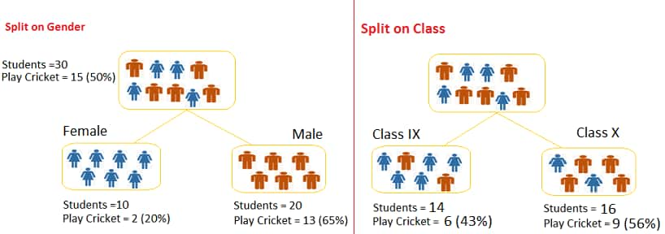
Split on Gender:
Gini for sub-node Female = (0.2)*(0.2)+(0.8)*(0.8)=0.68
Gini for sub-node Male = (0.65)*(0.65)+(0.35)*(0.35)=0.55
Weighted Gini for Split Gender = (10/30)*0.68+(20/30)*0.55 = 0.59
Similar for Split on Class:
Gini for sub-node Class IX = (0.43)*(0.43)+(0.57)*(0.57)=0.51
Gini for sub-node Class X = (0.56)*(0.56)+(0.44)*(0.44)=0.51
Weighted Gini for Split Class = (14/30)*0.51+(16/30)*0.51 = 0.51
Here Weighted Gini is high for gender, so we consider splitting based on gender

5)Decision trees can handle both categorical and numerical variables at the same time as features. There is not any problem in doing that.
Every split in a decision tree is based on a feature.
1. If the feature is categorical, the split is done with the elements belonging to a particular class.
2. If the feature is continuous, the split is done with the elements higher than a threshold.
At every split, the decision tree will take the best variable at that moment. This will be done according to an impurity measure with the split branches. And the fact that the variable used to do split is categorical or continuous is irrelevant (in fact, decision trees categorize continuous variables by creating binary regions with the threshold).At last, the good approach is to always convert your categoricals to continuous using LabelEncoder or OneHotEncoding.

6)lets assume there is a dataset as it haves 3 column if we consider the threshold value for the particular and after the seperation of each column w.r.t threshold value we will fing the gini value for each attribute of the column and also gini value of the particular column so lets say if column 1 has less impurity as compared to column 2 and column 3 that column will be consider as root node and other column will be consider as leaf node.
7)By hyperparameter tuning approach, In a decision tree there is a parameter called as maximum depth which helps us to control the depth layer of the decision tree.

8)1. Maximum depth :
Maximum tree depth is a limit to stop the further splitting of nodes when the specified tree depth has been reached during the building of the initial decision tree.
NEVER use maximum depth to limit the further splitting of nodes. In other words: use the largest possible value.
2. Minimum split size:
Minimum split size is a limit to stop the further splitting of nodes when the number of observations in the node is lower than the minimum split size.
This is a good way to limit the growth of the tree. When a leaf contains too few observations, further splitting will result in overfitting (modeling of noise in the data).
3. Minimum leaf size
Minimum leaf size is a limit to split a node when the number of observations in one of the child nodes is lower than the minimum leaf size.
9)Clear Visualization: The algorithm is simple to understand, interpret and visualize as the idea is mostly used in our daily lives. Output of a Decision Tree can be easily interpreted by humans.
Simple and easy to understand: Decision Tree looks like simple if-else statements which are very easy to understand.
Decision Tree can be used for both classification and regression problems.
Decision Tree can handle both continuous and categorical variables.
No feature scaling required: No feature scaling (standardization and normalization) required in case of Decision Tree as it uses rule based approach instead of distance calculation.
Handles non-linear parameters efficiently: Non linear parameters don't affect the performance of a Decision Tree unlike curve based algorithms. So, if there is high non-linearity between the independent variables, Decision Trees may outperform as compared to other curve based algorithms.
Decision Tree can automatically handle missing values.
Decision Tree is usually robust to outliers and can handle them automatically.
Less Training Period: Training period is less as compared to Random Forest because it generates only one tree unlike forest of trees in the Random Forest.
10) Disadvantages
Overfitting: This is the main problem of the Decision Tree. It generally leads to overfitting of the data which ultimately leads to wrong predictions. In order to fit the data (even noisy data), it keeps generating new nodes and ultimately the tree becomes too complex to interpret. In this way, it loses its generalization capabilities. It performs very well on the trained data but starts making a lot of mistakes on the unseen data.
High variance: As mentioned in point 1, Decision Tree generally leads to the overfitting of data. Due to the overfitting, there are very high chances of high variance in the output which leads to many errors in the final estimation and shows high inaccuracy in the results. In order to achieve zero bias (overfitting), it leads to high variance.
Unstable: Adding a new data point can lead to re-generation of the overall tree and all nodes need to be recalculated and recreated.
Not suitable for large datasets: If data size is large, then one single tree may grow complex and lead to overfitting. So in this case, we should use Random Forest instead of a single Decision Tree.

